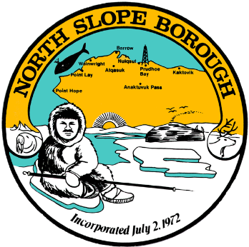
North Slope Borough Department of Health & Social Services
Utuqqanaaqagvik - Senior Citizens’ Center

• PO Box 69 Barrow, AK 99723 •

• Phone (907) 852-0276 • Fax (907) 852-0345 •

SHORT TERM TENANT APPLICATION
907-852-0276 OFFICE
907-852-0345 FAX

General Information
Full Name
Mailing Address
Daytime Phone # |  |  |  |  |  | Evening Phone #
Date of Birth |  |  |  |  | Emergency Contact Person
Emergency Contact Phone #
Emergency Contact Address
Type of Housing Requested |  |  |  | Single $30/night |  |  | ____________ | Double $35/night |  | ____________
To ensure availability of apartments at the Senior Center, Please provide your arrival date as much
in advance as possible (if known)
Date of Arrival: _________________________________________
Date of Departure: ______________________________________
List all the names of the tenants that will live in the unit:

1. Name:______________________ Relationship: __________________________ DOB: _______

2. Name:______________________ Relationship: __________________________ DOB: _______

Medical Information
1. Do you have a disabling condition that requires a caretaker, either part-time or full-time?
Yes: | Part-time | __________ |  | Full-time |  | __________ |  | No |  | _________
2. Will this caretaker live with you? |  |  | Yes |  | __________ |  | No |  | __________
3. Do you use any of the following:

Walker ______ Cane ______ Wheelchair ______

4. Please provide proof of all tenants’ T.B. results with this application.

S:\0408 Sr Cntr doc\short term rental application.doc

I certify the information on this application are accurate and complete to the best of my knowledge and understand that any future changes in my income or health status must be reported to the NSB Department of Health & Social Services immediately. I understand that false statements or information are grounds for termination or denial of housing assistance.

_____________________________________ ________________
Signature of Applicant Date

_____________________________________ _________________
Signature of Spouse/Caretaker Date

FOR OFFICE USE ONLY
Approval Date: | Apartment # | Key Issued
Rent Paid | Billing Information:

S:\0408 Sr Cntr doc\short term rental app page 2.doc

