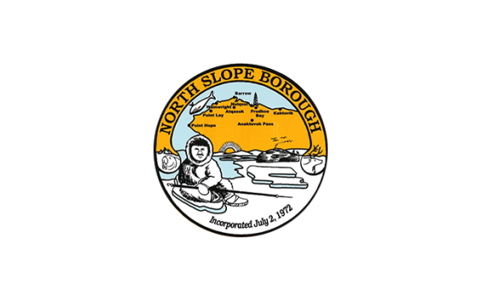
North Slope Borough Housing Dept.
GENERAL REQUEST
Email completed request to HousingUpgrades@north-slope.org
Name: |  |  |  |  |  |  |  |  |  | Today’s Date:
Village: |  |  |  |  |  |  |  |  |  | Phone:
House & Street: |  |  |  |  |  |  |  |  |  | Home Owner:
Request must meet approved categories for Emergency Winter Repairs:
- Basic Heating Repairs / Unsafe Plumbing System / Unsafe Electrical System
- House must be occupied by homeowner (cannot be rental)
- Repairs requiring extensive work may be referred to the NSB home loan program.
Select Category:
Heating |  | Electrical |  |  |  |  | Plumbing |  |  |  | Carpentry |  |  |  |  | Other
Select Priority Qualifiers:
Elder (over 60) |  |  |  | Children (under 6) |  |  |  |  | Disability |  |  |  |  | Unemployed
Describe Below:
- Your signature below indicates that you understand that this work is done as a community service and work may be performed as schedule permits. The North Slope Borough will not be responsible for any damages to property during performance of work requested.
- By signing below, you agree that the North Slope Borough, its officers, employees, contractors, and subcontractors, are not responsible for any damage to property from the requested work. Property includes, but is not limited to, buildings and equipment. Your signature also indicates that you agree to indemnify and defend the North Slope Borough, its officers, employees, contractors, and subcontractors from and against all claims, damages, losses, and expenses arising out of or resulting from the performance of the work.
Signature:
Submitted by:
Logged in by: |  |  |  |  |  |  |  |  |  |  |  | Record ID:
Assigned to: | NSB Housing Dept. |  |  |  |  |  |  |  |  |  |  | By:
 | Contractor: |  |  |  |  |  |  |  |  |  |  | By:
Verified by:

Requests to be logged into Housing Access Database

